Your Leadership Identity Grid Worksheet

Instructions: Follow Steps 1-4 in this packet to populate your leadership identity grid. The foundation of your leadership identity is your core values, which guide your action and form the ethical boundaries of what you do. On the right and left wings, your motivators & passions and leadership strengths give you power to effectively and sustainably excel as a leader. At the helm is your leadership purpose statement, which describes your objective as a leader and defines what sets you apart as unique in your leadership. Together, these four components complete your leadership identity.
Core Values
- ____________________
- ____________________
- ____________________
- ____________________
- ____________________

Leadership Purpose Statement

______________________________________
______________________________________
______________________________________
______________________________________

Leadership Strengths
- ____________________
- ____________________
- ____________________
- ____________________
- ____________________

Motivators & Passions
- _________________
- ___________________
- _____________________
- ___________________
- _________________

Step 1: Clarify your core values.
A core value is an ideal that you care so deeply about that it is integral to your life. Core values are not values that you aspire to live up to or ones that you like. They should be integral, no matter the circumstance, and often stem from your life events or early professional experiences you have had. They form the foundation of your leadership identity. Below is a sample, non-exhaustive list of values. Choose up to five for the base of your grid.
Achievement – a sense of accomplishment or mastery
Advancement – growth, promotion resulting from work well done
Adventure – new and challenging opportunities, excitement, risk
Aesthetics – appreciation of beauty in things, ideas, surroundings
Affiliation – interaction with other people, recognition as a member of a group, belonging
Affluence – high income, financial success, prosperity
Authority – position and power to control events and other people’s activities
Autonomy – ability to act independently with few constraints, self-reliance
Challenge – continually facing complex and demanding tasks and problems
Change – absence of routine, unpredictability
Collaboration – close, cooperative working relationships with groups
Community – serving and supporting a purpose that supersedes personal desires
Competency – demonstrating high proficiency and knowledge
Competition – rivalry with winning as the goal
Courage – willingness to stand up for beliefs
Creativity – discovering, developing, or designing new ideas or things; demonstrating imagination
Diverse perspectives – unusual ideas and opinions that may not be right or be popular at first
Duty – respect for authority, rules, and regulations
Economic security – steady and secure employment, adequate reward, low risk
Enjoyment – fun, laughter, joy
Family – spending time with partner, children, parents, extended family
Friendship – close personal relationships with others
Health – physical and mental well-being, vitality
Helping others – helping people attain their goals, providing care and support
Humor – ability to laugh at myself and at life
Influence – having an impact on attitudes or opinions of others
Inner harmony – happiness, contentment, being at peace with yourself
Justice – fairness, doing the right thing
Knowledge – the pursuit of understanding, skill, expertise, continual learning
Location – choice of a place to live that is conducive to a desired lifestyle
Love – involvement in close, affectionate relationships; intimacy
Loyalty – faithfulness, dedication to individuals, traditions, organizations
Order – stability, routine, predictability, clear lines of authority, standardization
Personal development – dedication to maximizing potential
Physical fitness – staying in shape through physical activity and healthy nutrition
Recognition – positive feedback and public credit for work well done; respect and admiration
Responsibility – dependability, accountability for results
Self-respect – pride, self-esteem, sense of knowing oneself
Spirituality – strong spiritual or religious beliefs, moral fulfillment
Status – being respected for a job or an association with a prestigious group or organization
Trustworthiness – being known as reliable and sincere
Wisdom – sound judgment based on knowledge, experience, and understanding

Step 2: Define your motivators & passions.
Part of your leadership identity grid involves naming your greatest motivators and passions. Motivators give power to your leadership. Motivators can be extrinsic or intrinsic in nature. Extrinsic motivators have their origins in the external world and include things like monetary compensation, power, recognition, status, prestigious associations, and other external definitions of success. Intrinsic motivators have their origins within you and include things like growth, mastery, autonomy, and meaning. Both extrinsic and intrinsic motivators are powerful resources and must be balanced to sustain your leadership. Choose up to five extrinsic or intrinsic motivators for the left wing of your grid.
Extrinsic Categories | Intrinsic Categories
Monetary compensation | Engaging in personal growth/development
Power | Doing a good job
Prestigious title | Helping others
Public recognition | Leading and organizing others
Social status | Being with people you care about
Competition | Finding meaning from your efforts
Association with prestigious institutions | Being true to your beliefs
 | Making a difference in the world
 | Influencing others
 | Autonomy

Add also to the left wing of your grid up to three passions – the kinds of activities that you love to do and derive joy and meaning from.
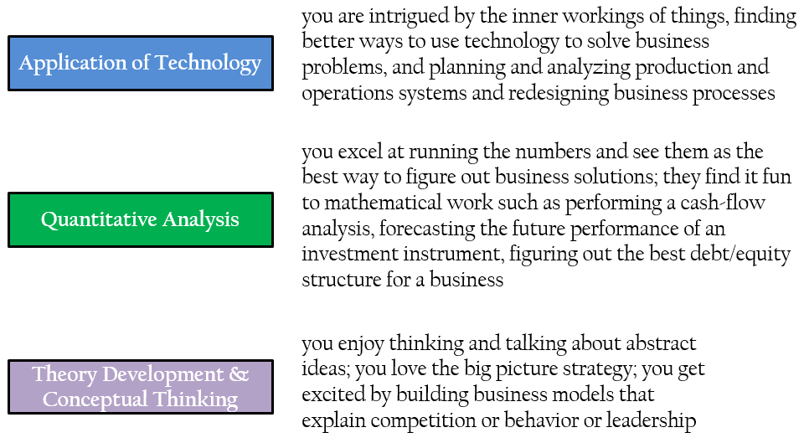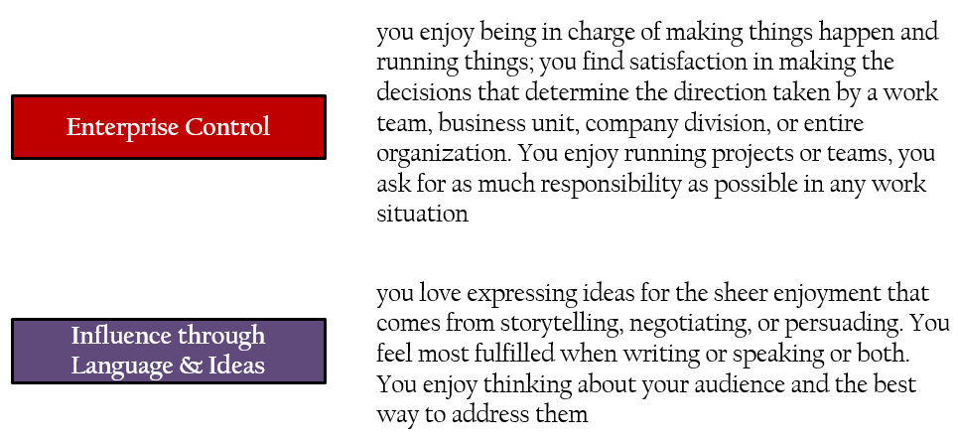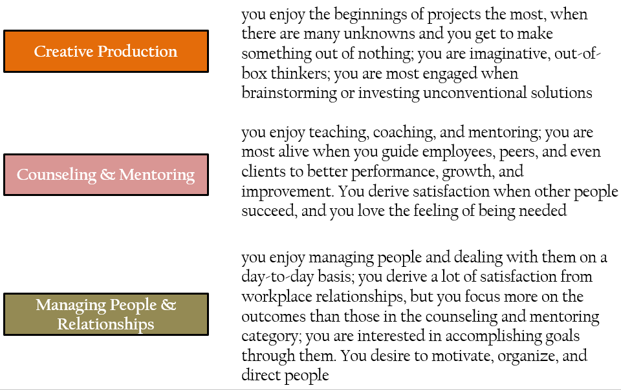

Step 3: Define your leadership strengths.
Research has demonstrated that leaders are most effective and most fulfilled when they tap into their greatest strengths. Below is a non-exhaustive list of leadership strengths. Think about moments when you felt most proud about who you were as a leader and the strengths that you relied on in those moments. Choose up to five strengths for the right wing of your grid.

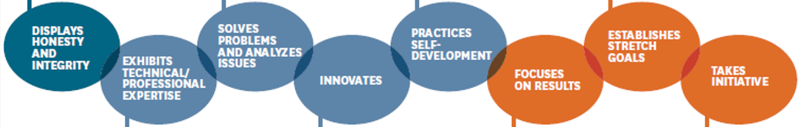


Step 4: Summarize your leadership purpose.
Having worked through your core values, your motivators & passions, and leadership strengths, it is time to craft a unique set of words that summarizes what you hope to achieve as a leader, that taps into your core values, motivators and passions, and leadership strengths, and articulates what you want to be remembered for as a leader.
